Pennsylvania Farmland Preservation Association

AGENDA – In-Person Meeting – Zoom available

Thursday, May 21, 2026 - 8:00 AM to 4:00 PM
Centre County - Willowbank Building – 420 Holmes Street, Bellefonte, PA

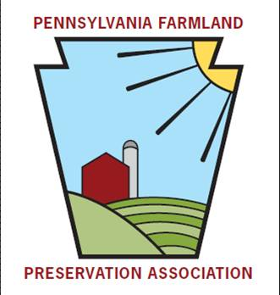
A BIG Thank You to our Sponsor:


8:00 Registration – Continental Breakfast is available at 8:00 am
9:00 Welcome, Introductions, Recognitions, and Milestones Amanda Burkard-Sell

9:30 Business Meeting
A. Opening
1. Call to Order and Poll of Voting Members Caroline Sinchar
B. Business Agenda Items
1. Minutes of Fall 2025 Virtual Meeting Caroline Sinchar
2. Treasurer’s Report Kelse Brown
3. Membership Committee Caroline Sinchar /Emily Goense

C. Old Business Amanda Burkard-Sell

D. Legislative Updates Matt Knepper/Eric Naylor
E. New Business
1. Proposed Bylaws Amendment to Change Officer Voting .Amanda Burkard-Sell
2. Quarterly Member Workgroups…………………………………………Amanda Burkard-Sell

The Official Business Meeting will remain open until the end of the day, permitting action on any issues…

10:30 Short Break

10:45 Penn State Dickinson Law Audrey Thompson, Esq.
Laws/regulations governing agriculture in PA (including Nutrient and Odor Management Act, Right to Farm, etc.) and ACRE

12:00 Lunch

1:00 FRPP / ALE Stewardship…………………………………………………………Mick Albert, NRCS
Easement splits/subdivisions and utility ROW requests on Federal Easements

1:30 PDA Updates Stephanie Zimmerman and Staff
PaFarmland update with Q&A

2:30 Roundtable Discussion
- Record keeping
- Other topics as suggested by members

4:00 Wrap-up, Motion to Adjourn Business Meeting, and DOOR PRIZES! Amanda Burkard-Sell

